**Assignment Front Cover Sheet**

**TITLE PAGE**

**Programme of Study: Foundation Degree in Applied Computing**

**ASSIGNMENT**

**NAME OF STUDENT: JACOB EDWARD STORER YEAR OF STUDY 2**

**College Email Address:**

**Unit code: LP20552A1 Unit Title Mobile Technologies**

**Unit Tutor Danielle Vass** [**vassd@citybathcoll.ac.uk**](mailto:vassd@citybathcoll.ac.uk)

**ASSIGNMENT TITLE:**

**LP20539A1: App Development**

**WORD COUNT 739 DATE SUBMITTED 12/05/2015**

**(May not exceed +/- 10% of limit) (Late submissions may be penalised)**

**CHEATING AND PLAGIARISM DECLARATION**

**I confirm the following**

*I have read and understood the following sources that explain cheating and plagiarism;*

*the University of Bath website at* [*http://www.bath.ac.uk/library/help/infoguides/plagiarism.html*](http://www.bath.ac.uk/library/help/infoguides/plagiarism.html)

*and my programme handbook*

*To the best of my knowledge, my work does not contain plagiarised material.*

**SIGNATURE: JACOB EDWARD STORER**

Ensure that you have completed your work as specified by the deadline date and time (**Thursdays 4pm**)

You must submit one electronic copy of your work to the relevant location as detailed in the assignment brief and/or the Regulations for Submitting Assignments document.

You must keep a copy (electronic and paper) of this assignment for your own records.

|  |  |  |  |  |  |  |
| --- | --- | --- | --- | --- | --- | --- |
| bath college MONO copy | | Assessment feedback form Students must attach this form and the assessment brief to work submitted for assessment | | | | UoB_logo-blu-xs |
| Hand out date: | | *(as per assessment plan)* | Hand in date: | | | *(as per assessment plan)* |
| Assessor: | | Danielle Vass | Date received: | | |  |
| Assessor’s comments | | | | | | |
| Percentage mark awarded |  | | | Contribution to Unit Marks | | 60% |
| Unit Outcomes | * Analyse and recommend an appropriate mobile solution for the workplace. * Demonstrate an understanding of a variety of mobile technologies (e.g. Mobile-device based languages, operating systems, internet browsers and environments). * Produce a mobile application for a given specification. * Research current developments in emerging mobile device techniques. | | | | | |
| Assessor’s signature |  | | | | Date |  |
| Moderator’s signature |  | | | | Date |  |

# Aims

This assignment aims to provide evidence for the learning outcomes of the unit. (See above).

It will demonstrate your ability to do the following:

* Use GUI design and visual programming skills in a given language.
* Show good problem solving skills, Time management and Planning and prioritisation of tasks.
* Prepare high quality reports and documentation to support applications.
* Present information appropriately.
* Perform user demonstrations and prepare questionnaires to aid critical evaluation of products.

# Scenario

You are tasked with creating an Android app for a travel agency to demonstrate their travel destinations.

A requirement of the app will be to display photographs of travel destinations using a popular web API Flickr (different web API you must email a request to the lecturer to get agreement).

You must also come up with at least one additional feature e.g. allowing users to favourite photographs, or displaying other additional information on locations such as the current weather.

Finally, you must demonstrate a good HCI and incorporate some Material Design aspects into your app.

Your app is required to run on Android 5.0 (SDK 21) and above. It is not necessary to have a real Android device yourself, as Android Studio will provide an emulator to use.

# Tasks

1. Working Android App

- Marked in a student viva - students demonstrate and defend their work one-on-one

2. App Report

a. A mock app store listing

b. What you learned

c. What your proud of

d. What you could improve (programming wise)

e. Features you’d like to add to your app if you had more time

f. Differences you see between building desktop and mobile apps

3. Presentation on the past / present / future of mobile technologies

# SubMISSION

You should submit a folder containing:

1. Android app project folder (all source code)
2. Presentation exported as a folder of images (PNG preferable)
3. Report as a word document

# Grading Criteria

|  |  |  |  |
| --- | --- | --- | --- |
| Element | Wt. | Criteria | Marks |
| Task 1: Android App | 70% | Splash Screen | 0 – 10 |
| List of Destinations Screen | 0 – 10 |
| Specific Destination Screen | 0 – 10 |
| Pictures from API | 0 – 10 |
| Bonus Feature(s) | 0 – 10 |
| HCI (Material Design) | 0 – 10 |
| Quality of the viva defence | 0 – 10 |
| Task 2: Presentation (Past, Present, Future of mobile) | 20% | Standard of English | 0 – 5 |
| Multiple Operating Systems mentioned (Android, iOS, Blackberry, Windows Mobile) | 0 – 8 |
| Future tech | 0 – 7 |
| Task 3: Report | 10% | App Store Listing | 0 – 2 |
| What you Learned | 0 – 1 |
| What your Proud of | 0 – 1 |
| Improvements | 0 – 1 |
| Additional Features | 0 – 2 |
| Differences between Mobile and Desktop | 0 - 3 |

Contents

[Mock App Store Listing 6](#_Toc419230788)

[Screenshots 7](#_Toc419230789)

[What I have learned 8](#_Toc419230790)

[What I am Proud Of 8](#_Toc419230791)

[What Could Be Improved 8](#_Toc419230792)

[Additional Features 8](#_Toc419230793)

[Development of Desktop Apps and Mobile Apps 9](#_Toc419230794)

Report on Android Development

# Mock App Store Listing

**Title:**

Jacob Storer’s Travel Viewer

**Short Description:**

This App facilitates the viewing of pictures of locations from around the world.

**Full Description:**

This newly released App facilitates the viewing of pictures of various locations from around the world. Presently, the App includes a list of ten specific cities, along with their respective countries and flags, an ‘About’ screen, which provides basic information about the developer of this App, and a simple splash screen, which is to be used to effectively navigate between the various features of the program.

Upon selecting a specific location, the name of the city and country selected will be displayed, as well as its respective flag, and a grid of images, which are imported immediately from the internet, will be displayed.

This App has been designed with common Human-Computer Interaction principles, thus it displays all information with clarity and an attractive colour scheme.

Future updates will possibly include a search function, which users will be able to utilize in order to find places of their own choosing.

# Screenshots

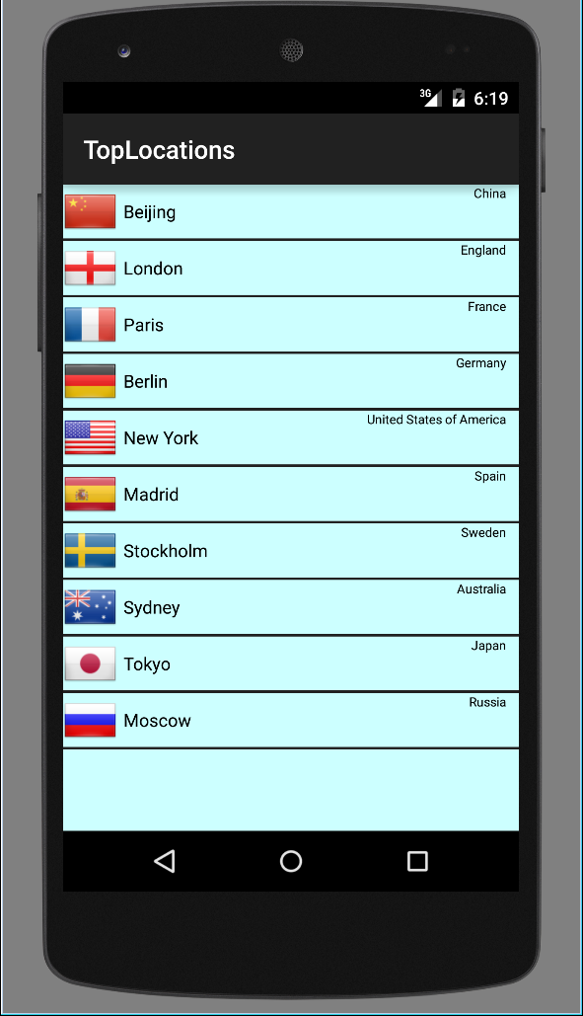

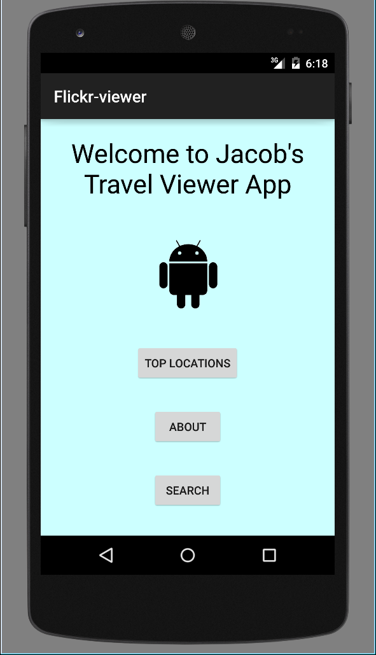

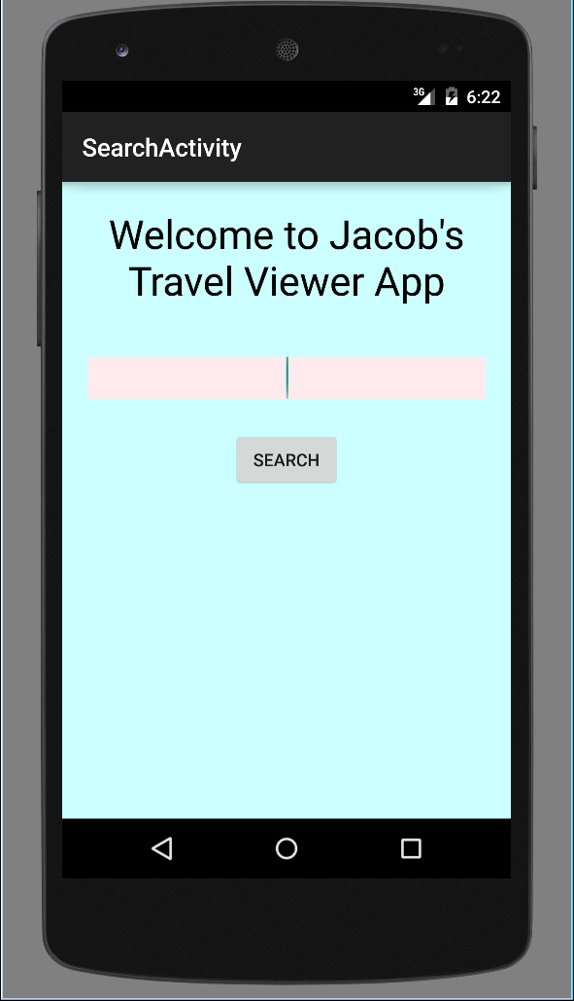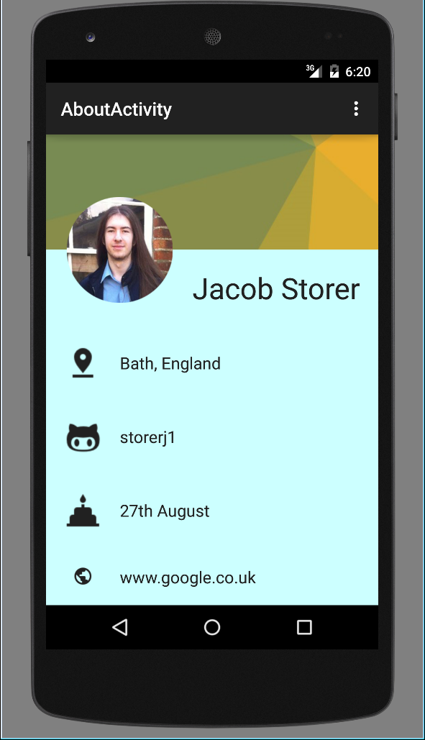

# What I have learned

Over the course of the Mobile Technologies module, I have learned a great deal about the development of Android applications, and the complexities of trying to draw information from external sources, such as the Internet, into an application, though ultimately I failed to implement a system like this in my final application. I have also learned much about the development of layout (.XML) files, and how similar it is to the development of HTML files for websites.

While HCI concepts were not newly introduced within the Mobile Technologies module, they were reinforced, and thus improving my understanding of what makes an application attractive and more user-friendly.

As a critical component of developing Android applications, I have learned some basics of the Java language as well, particularly the typical error messages that can arise when alterations and mistakes are made.

# What I am Proud Of

Over the course of the Mobile Technologies module and the development of the Travel Viewer App, I have become proud of the following:

* The quality of the appearance of my App, particularly the ‘About’ screen.
* The knowledge of layout files that I have acquired.
* The efficiency with which I can navigate through the subfolders of my Android project, such as navigating between layout and java files.

# What Could Be Improved

With additional development time, the following aspects of my application could be improved:

* The functionality of the imported images portion of the application, which presently does not work.
* The overall presentation of the application could be slightly improved.
* The code could be more thoroughly analysed and potentially removed, in order to reduce redundancies and to improve the overall efficiency of the code.
* Alternate and more efficient methods, for the features found in the application, could be researched and implemented.
* Image files could be more thoroughly analysed and potentially removed, in order to reduce redundancies and to improve the efficiency of the application.

# Additional Features

Below is a list of additional features that could be added with additional development time and understanding:

* A complete ‘Search’ function, which I had already begun, though was not able to get too far. This search button would allow for users to search for countries or places of their own choosing.
* A ‘Favourite Locations’ feature could be implemented, in which users will be able to mark specific locations as part of their list of favourites. This list could be called upon by another button, to improve navigation.
* A ‘Current Weather’ feature, which could detail the current condition of the climate in the desired location.
* A ‘Full Screen’ feature, with which the user could enlarge an image of the location they are currently viewing so that it fits the entire screen, and removes all other interface elements.

# Development of Desktop Apps and Mobile Apps

There are numerous differences between the development of desktop applications and mobile applications. One of the key differences between the development of desktop apps and mobile apps is that mobile applications require emulations of mobile devices, as specific devices have specific hardware and operating systems. Mobile applications are also not only run from fixed locations, so additional variables could be developed with the location of the user in mind. Mobile applications also must require less processing power and are limited, in that respect, as mobile devices are simply not as powerful as desktop machines.